1. The methods of requirements gathering are social investigation and user survey (figure 1). Mainly collect the functional and non-functional requirements.

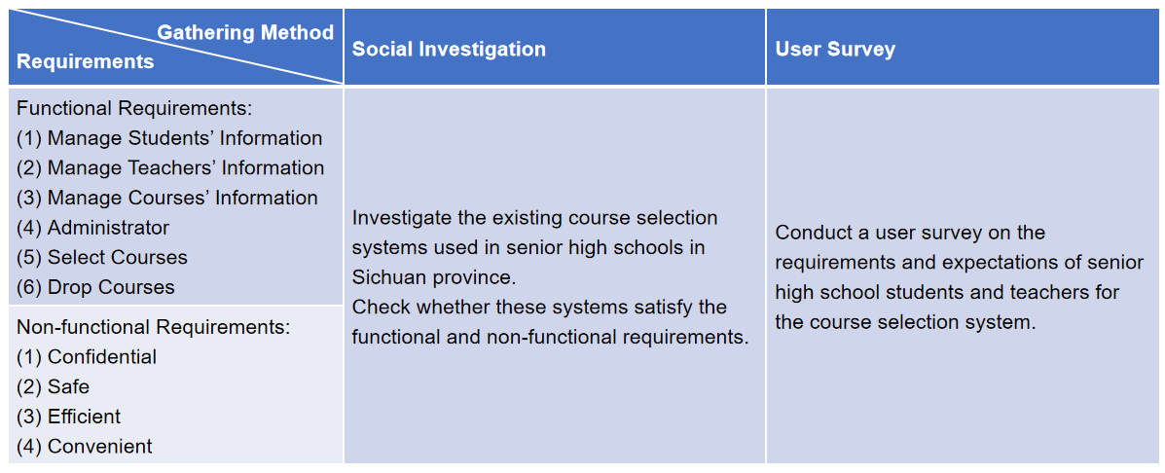

Figure 1: Requirements Gathering